Mobile/Web POS

User Manual

Version 0.2

Contents
Android POS User Manual 4
Start Application First Time 4
Device Registration 5
Login Screen 6
Love Mode 7
Settings 8
Merchant Information & Payment Processor 8
Sale Options 9
GiftSTS Card Activation 10
GiftSTS Card Balance Enquiry 11
Sale Transaction 12
Select Item 12
Payment Process – CASH 13
Payment Process – CREDIT 15
Refund Transaction 17
Select Refund Option 17
Exchange Transaction 18

Android POS User Manual

Launch Application First Time
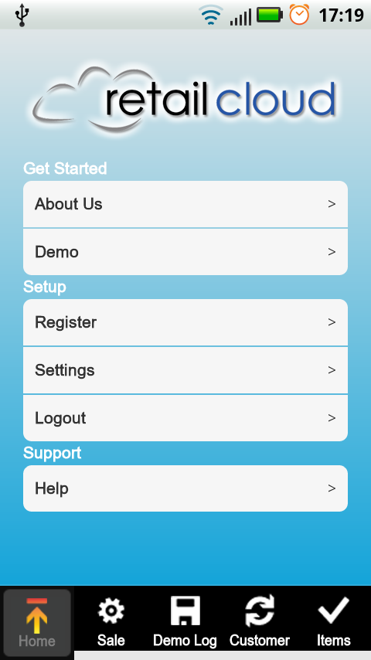 | - When Application starts without registration, application will run in demo mode.  - In demo mode we cannot make any payment transaction except Cash & Demo Card Transaction.  - User cannot logout in DEMO Mode.  - For Transaction, user can select Demo from Menu or Sale from below tabs.  - Select Register Menu for LIVE Mode. More details on Section[Register Merchant Account ].  - Using Setting Menu, User can View /Update Merchant & Processors Data. Topics for Help is not available yet.

Device Registration
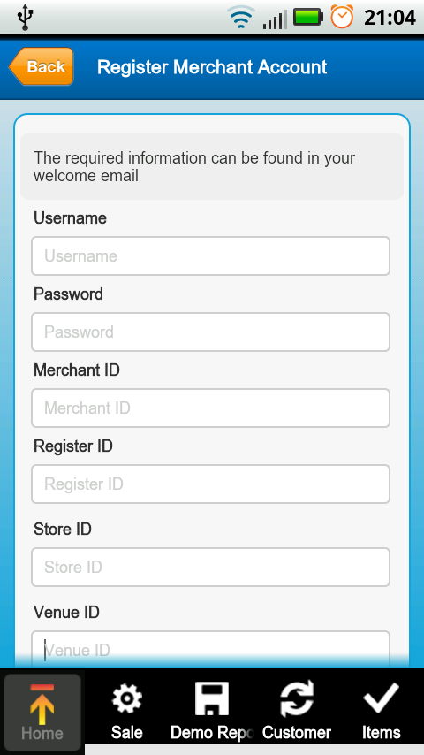 | - Enter all Fields given on the screen (all Fields are mandatory).  - After validation of credential by server, merchant data and processors data will be downloading and then application data will be synchronized like user details, item details, last transaction id etc.  - After successful registration application will be reset. and all old (i.e. from DEMO MODE) items, custormers and transactions will be deleted.  - Then the pplication prompts for Userid and password for accessing the Live Application.

Login Screen
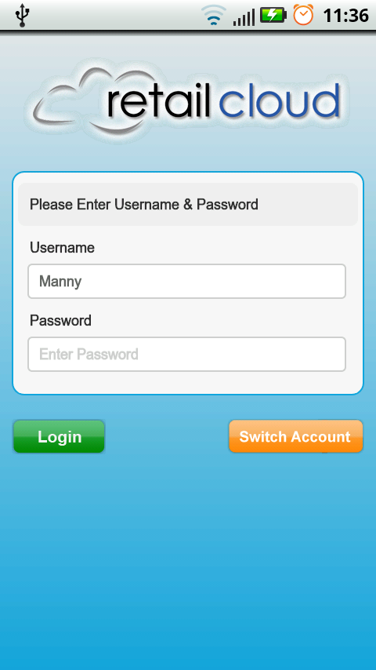 | - Enter Username and Password.  - Click on Login button to verify credentials.  - If device has internet connection, authentication will be done by server else authentication will be done locally on device.  - Username may be filled with someusername, it is because of the user already logged in before and close application without logout.  - At that time, user can use Swich Account to login with another username and password.  - Press Device Back Button to exit application.

Love Mode
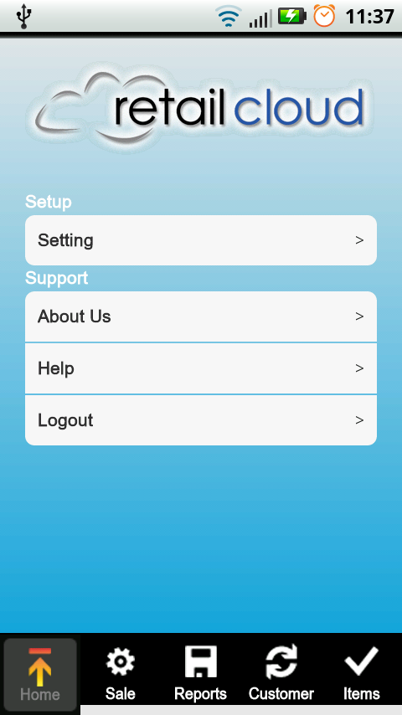 | - Home Screen will change after registration of merchant.  - Hereafter, we can make live transcation with available payment processors. More details on Section [Payment Screen].

Settings
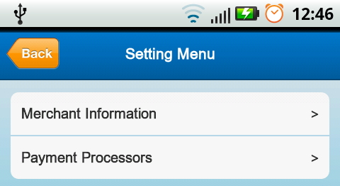 | - We can update & View Merchant & Payment Processors from Setting Menu.

Merchant Information & Payment Processor
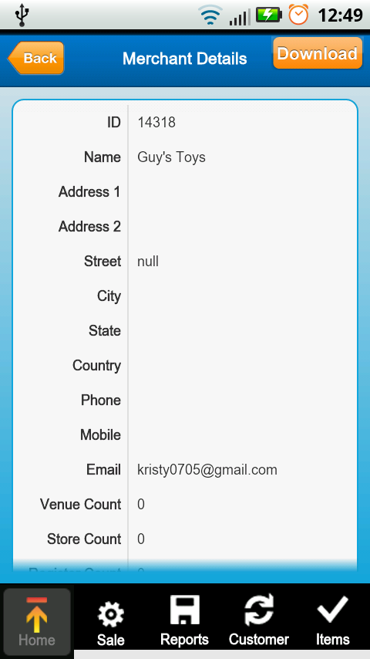 | - On this screen, user can see the merchant details.  - Also can update merchant details. Merchant Update will be used to update the details of Merchant if any changes on server side.  - If device is not registered, this screen will prompt for registration and navigate to Registartion process screen.  - If device is already registered and pressed DOWNLOAD (can be replaced by UPDATE) button, screen will navigate to “Update Merchant Account” Screen. On Update screen Merchant ID, Register Id, Store ID & Venue ID will be same as entered while Registration and cannot be modified. Merchant have to enter only Username & password and submit the details.  - Above same steps applicable for Payment Processor

Sale Options
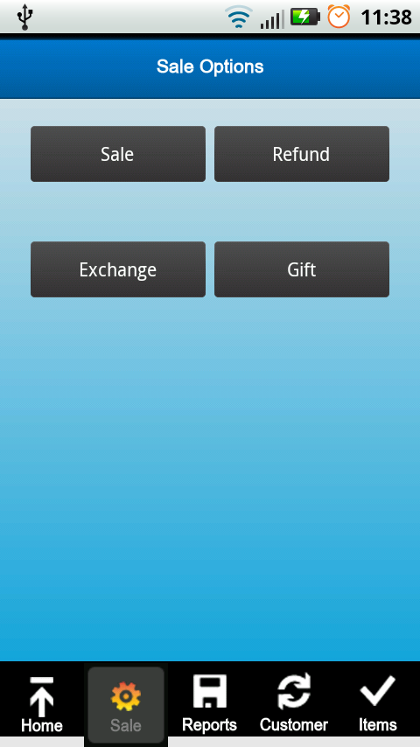 | This is main Screen for all transaction.  - From this screen we can make different types of transaction like Sale, Refund or Exchange.  - Activation of GiftSTS card as well as balance Enquiry can be done from this screen only.

GiftSTS Card Activation
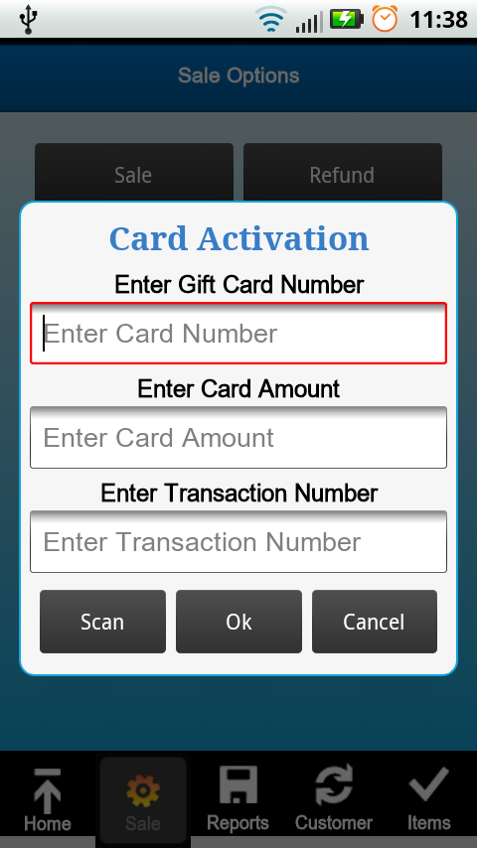 | - On Click, Gift Button from Sale Screen, two options will be popup i.e. Activation or Balance Enquiry (Select Activation).  - Before activating account, we have to make sale transaction. With new sale transaction number we can do activation of Gift Card.  - On clicking Activation, another popup dialog will appear to prompt Gift Card Number, Activation Amount, Transaction Number. (please refere above point for Transaction Number).

GiftSTS Card Balance Enquiry
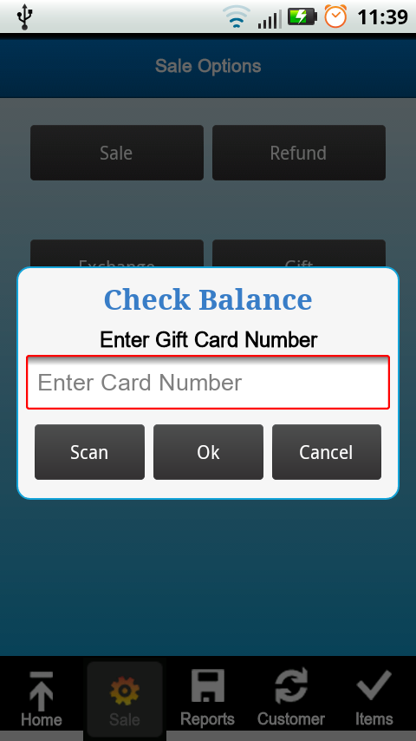 | - On Click, Gift Button from Sale Screen, two options will be popup i.e. Activation or Balance Enquiry (Select Balance Enquiry).  - On Click Balance Enquiry, another popup dialog will appear to prompt Gift Card Number for which we are making request of Balance Enquiry.  - If Card is valid and activated then in next dialog box available balance will be shown (Please refer Below Image.  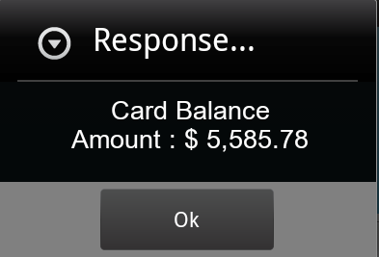

Sale Transaction

Select Item
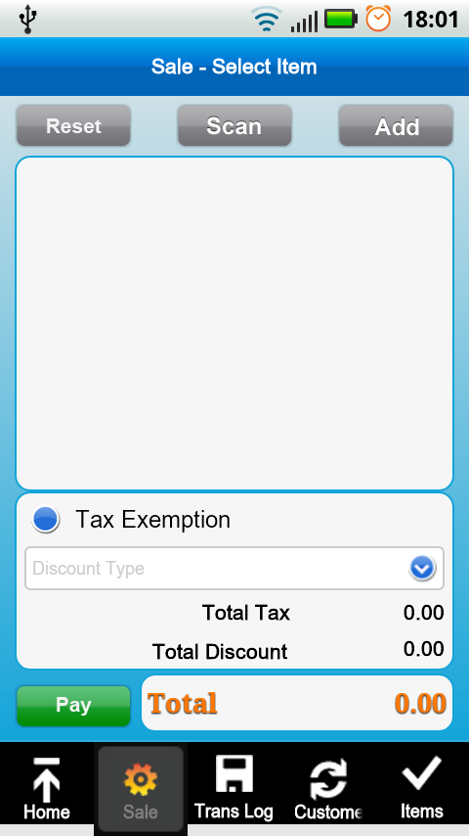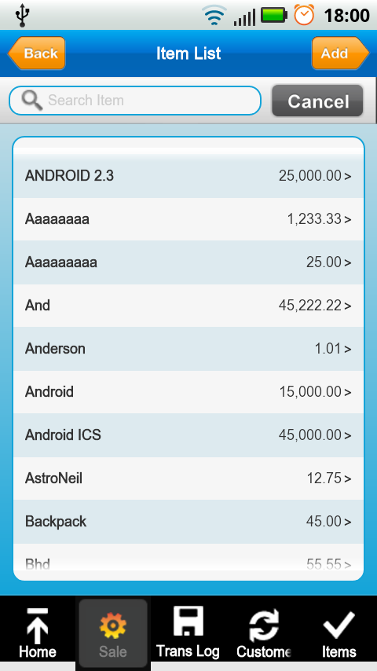  Screen (1) Screen (2)  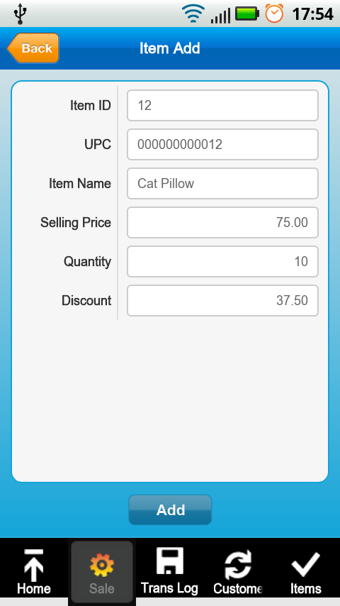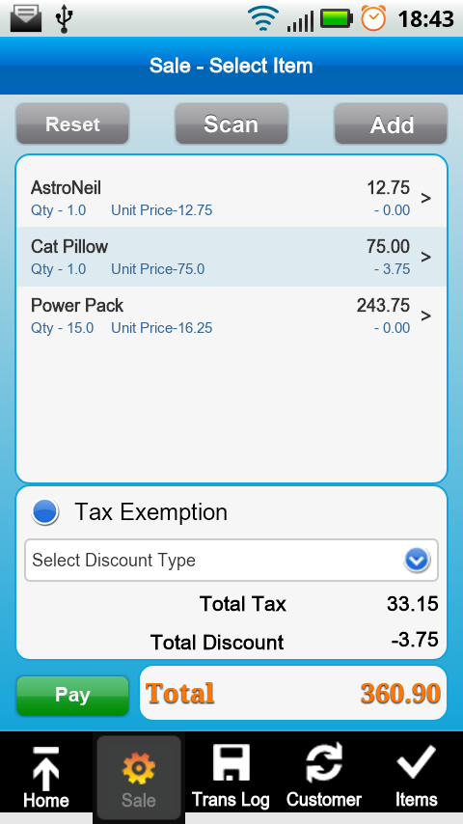  Screen (3) Screen (4) | - On clicking Sale button from Sale Screen, flow will navigate to Sale Select Item Screen.  - Add Button is used to select Items from Item List.  - If you want to add new Item in Item List then click on Add Button at the top Right Corner.  - If you want to select existing item then click on existing item from list.  - Enter the Quantity of Item to sale. (If discount is applied for the item then discount will be calculated accordingly.)  - Click Add button and check the item details in Sale Select Item Screen.  - If you want to exempt Tax then click on Tax Exemption option  - If you want to make Transaction level Discount then Select Discount from dropdown. Selected Discount will set for each selected items. For Example.  If you select D1 from the list, this option having 5 % discount. Then this 5% discount will set to each selected item.  - You can add item through scanning barcode also.  - Reset Button used to clear all the selected Items.  - Press Pay button to proceed for Transaction.

Payment Process – CASH
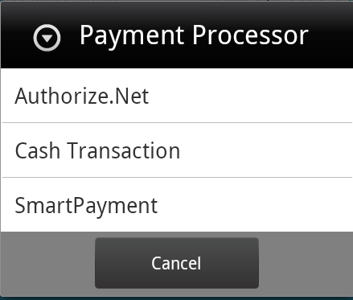  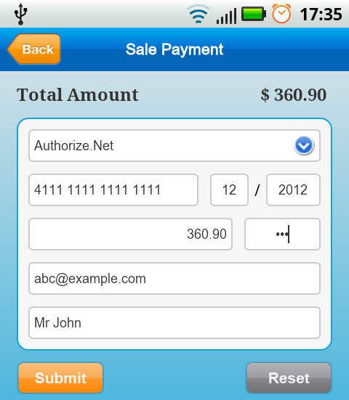  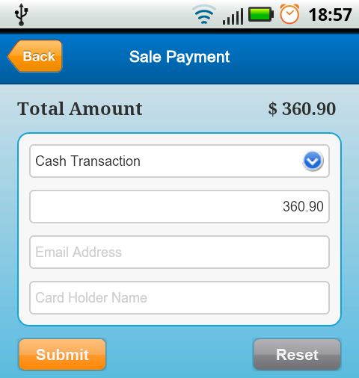 | - Select Payment Gateway for payment from top dropdown list.  - If Select Authorize.NET then enter all mandatory fields details like Card#, Expirty Date, CVV.  - If Select Cash Transaction, no field is mandatory except transaction amount.  - Split Transaction Amount can be made by changing transaction amount.  - Press Submit Button to proceed.

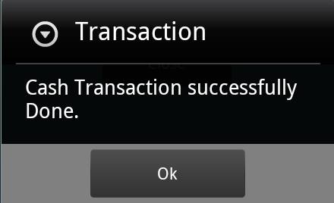  Screen (1)  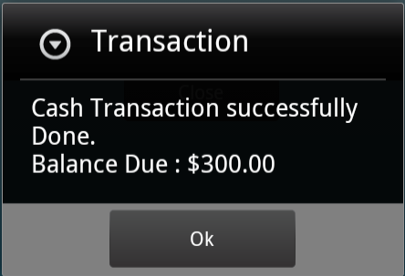  Screen (2)  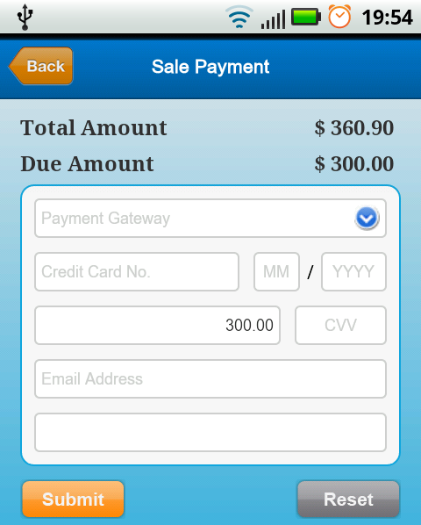  Image(3) | - If Full Payment, Cash Transaction has been Successful message will appear [Screen (1)].  - If Partial Payment, Cash Transcation has been successful, dialog appears for partial payment.  - Screen navigate to Sale Payment Screen for remaining amount and shows Due Amount [Screen (3)].  - After Complete Transaction, Navigation to Transaction Details Screen [Image(4)]  - Click Button Details to view Sold Items for this Transaction.  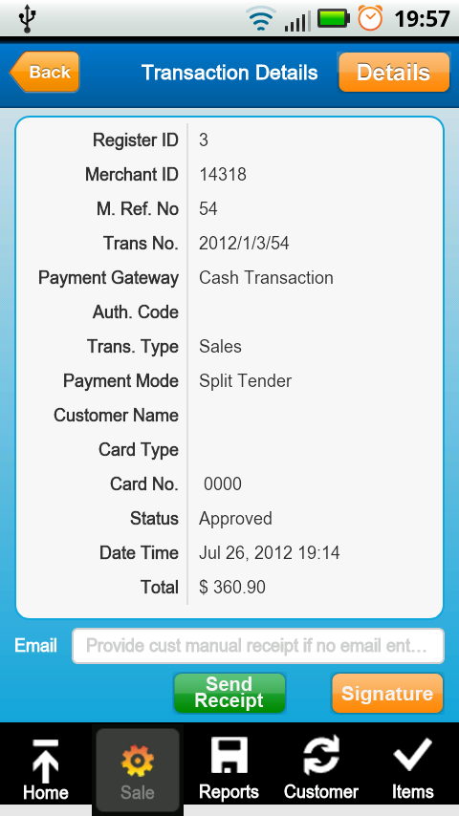  Image(4)

Payment Process – CREDIT
- Select Payment Gateway for payment from top dropdown list.
- If Select Authorize.NET then enter all mandatory fields details like Card#, Expirty Date, CVV.
- If Transaction for refund, you will be prompted for authnet previous transaction id.
- Split Transaction Amount can be made by changing transaction amount.
- Press Submit Button to proceed.

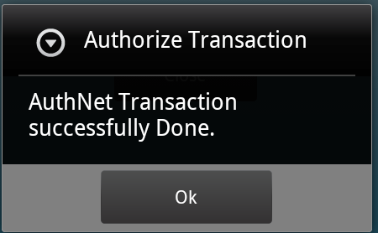  Screen (1)  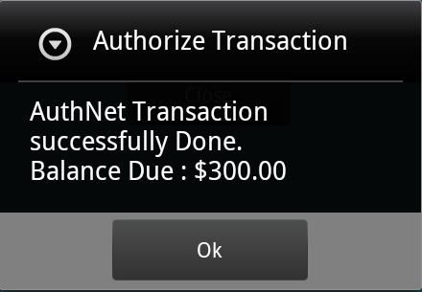  Screen (2)  Image(3) | - If Full Payment, AuthNet has been Successful message will appear [Screen (1)].  - If Partial Payment, AuthNet has been successful, dialog appears for partial payment.  - Screen navigate to Sale Payment Screen for remaining amount and shows Due Amount [Screen (3)].  - After Complete Transaction, flow navigates to Transaction Details Screen [Image(4)]  - Click Button Details to view Sold Items for this Transaction.  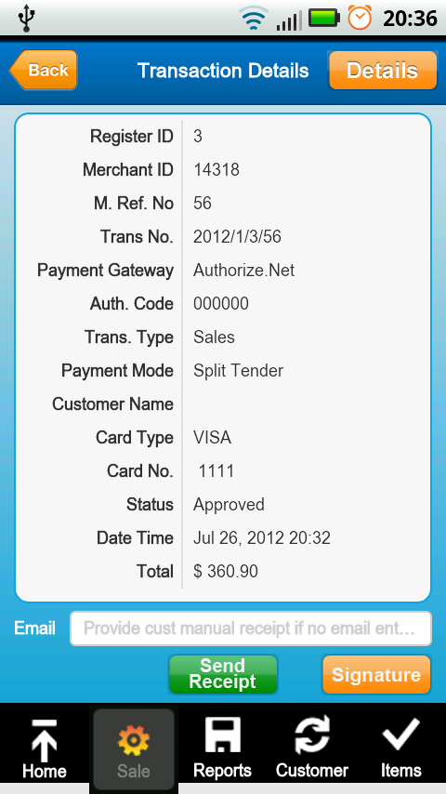  Image(4)

Refund Transaction

Select Refund Option
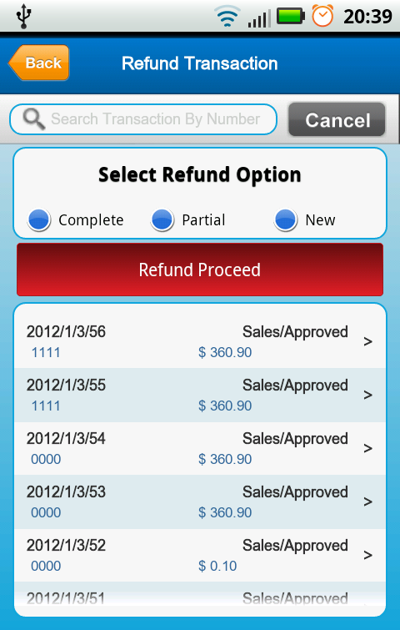  Screen (1)  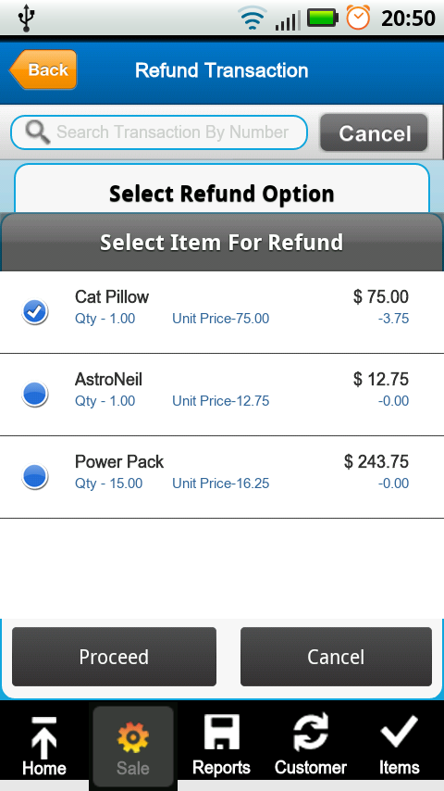  Screen (2) | - On Click, Refund button from Sale Option Screen, screen will navigate Refund Transaction Option Screen.  - Refund Transaction can be made in three Options.  - Complete refund against existing transaction  - Partial Refund againt existing transaction with selected items.  - New Transaction if transaction number not available.  - Complete Refund Transaction  - Select transaction number and screen will navigate to Refund Select Item.  - On this screen you cannot add, scan or reset item.  - Press Pay Button to precced for Payment.  - Payment procedure same as per the sale. Please refer Section [Payment Process Cash / Authorize.Net]  - Partial Refund Transaction  - Select transaction number and Item list will appear to select item for refund. Here minimum item should be selected.  - On click Proceed button from Item Popup window, screen will navigate to Refund Select Item.  - On this screen you cannot add, scan or reset item. You can only edit item quanity  - Press Pay Button to precced for Payment.  - Payment procedure same as per the sale. Please refer Section [Payment Process Cash / Authorize.Net]  - New Refund Transaction  - New transaction is same like sale transaction flow.  - Press Click here to refund transaction after selecting New Refund Option  - Screen will navigate to Refund Select Item.  - Here you can add, scan and reset item.  - Press Pay Button to precced for Payment.  - Payment procedure same as per the sale. Please refer Section [Payment Process Cash / Authorize.Net]

Exchange Transaction
Screen (1)  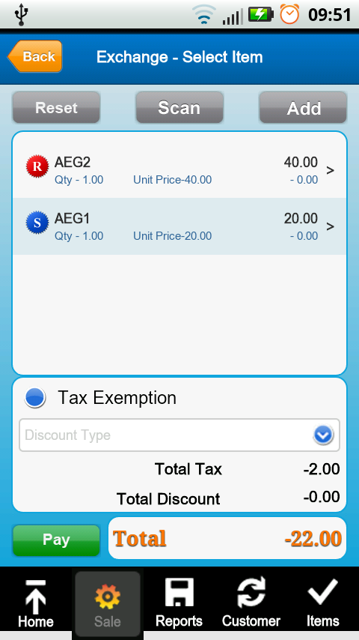  Screen (2) | - On Click, Exchange button from Sale Option Screen, screen will navigate Exchange Select Item Screen.  - Exchange Transaction is combination of Sale & Refund transaction.  - Press Add Button and select item type like sale or refund. After selecting item type you willnavigate to item list to add item for transaction.  - Item can be seen seperated by (Refund) and (Sale) [Screen(2)]  - In this type transaction Refund & Sale depends on total value. If Total Value is negative (-ve) then transaction will be considered as Refund. If Total Value is positive (+ve) then transaction will be considered Sale.  - Payment procedure will be same as per the Sale/Refund transaction. Please refer Section [Payment Process Cash / Authorize.Net].

